

Currently, with Buffer, you can connect to the following types of accounts:
- Facebook: Profile, Page, and Group (for groups you do have to be the admin)
- LinkedIn: Profile, Company Page, and Group (for groups you do have to be the admin)
- Twitter: Profile.
- Google+: Business Pages.
- Pinterest accounts (On Awesome and Business)

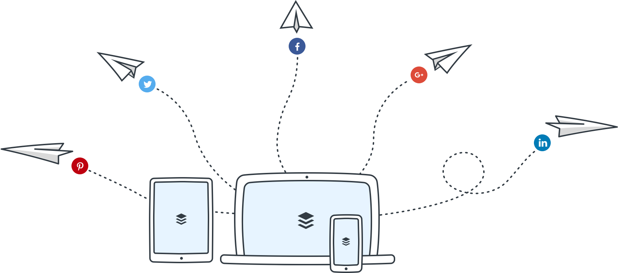

http://futurism.com/check-out-the-wikkelhouse-a-customizable-cardboard-house-that-lasts-for-decades/

